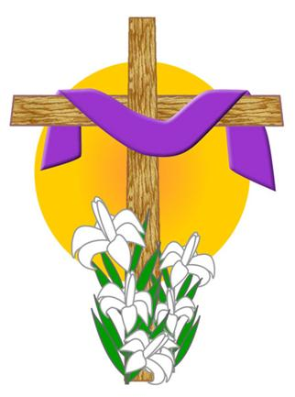
St Mary’s Catholic Church
Toccoa, Georgia 30577
2018 Lenten Season schedule

Ash Wednesday, February 14th:
9:30 am; The Liturgy of the Word, prayer service w/distribution of ashes.
5:45 pm; Mass w/distribution of ashes.

Friday, February 16th thru Friday, March 23rd:
5:00 pm Stations of the Cross w/Deacon Ollick

Saturday, March 3rd:
9:00 am-3:00 pm; Lenten Retreat w/Deacon Ollick (Parish Hall)
(light breakfast/lunch will be served; MUST sign up, please.)

Wednesday, March 7th:

6:30 pm; Parish Penance Service

Holy Week

Holy Thursday, March 29th: 5:45 pm Mass

Good Friday, March 30th: 5:45 pm ‘The Lord’s Passion’.

Saturday, March 31st: NO (EVENING) MASS AT ST MARY’S

Easter Sunday, April 1st: 8:30 am Mass (children’s egg hunt afterwards).

